CHERITON BISHOP PRE-SCHOOL
NEWSLETTER 2nd HALF SPRING TERM 2022

Hope everyone has a really good half term break!!
Our topic for this next half term will be, ‘Traditional tales.’ The children have appeared to thoroughly enjoy the ‘Book of the Week,’ so we have decided to take this a step further – alongside this we will also be looking at a variety of traditional tales, using them as the basis for our crafts and role play.

The following six weeks will be as follows –
OUTLINE PLANNING -
WEEK 1 – Number – ‘The Three Billy Goats Gruff.’ & ‘The Three Little Pigs.’ Thurs -World Book Day * See below.
WEEK 2 – Number continued – ‘Goldilocks and the Three Bears.’
WEEK 3 – Food – ‘The Very Hungry Caterpillar’ & ‘The Little Red Hen.’
WEEK 4 – Journeys – ‘Little Red Riding hood,’ & ‘We’re going on a Bear Hunt.’ Mother’s Day crafts
WEEK 5 – Planting and growing – ‘Jack & the Beanstalk’ & ‘The Enormous Turnip.’
WEEK 6 – TBC – led by children’s interests at the time. Easter crafts.

WORLD BOOK DAY - Thursday 3rd March 2022 All parents are invited to join the whole school 3pm in the playground for the Parade, Book swap and Cake Sale. More details can be found in your weekly Preschool email.

SNACK DONATIONS – This is another request for snacks for the next half term. Thanks very much for your support with this. One packet of crackers, digestives or piece of cheese from each family will see us through this half term. Thank you! *Please ignore this message if you have made a donation just before the end of last half term.

SESSION TIMES REMINDER– Mon/Tues/Wed/Thurs; drop-off between 8.45* - 9am, pick-up 3 - 3.15pm. *Please do not arrive any earlier than 8.45am as staff will still be setting up activities for the day.
Before lunch pick up – 11.30 am. After lunch pick-up/drop-off – 12.45pm.

FAMILY PHOTO DISPLAY – Please send in a photo of your family, home, pet or all for display on our ‘Family’ board. This is always really popular with the children and great for discussion.

’FOREST SCHOOL’ TYPE ACTIVITIES. – We will continue to visit the scout field on Tuesdays, weather permitting. Please send your child into school wearing their outdoor waterproofs etc. Everyone needs to bring a named coat for every session. If coming in with hats, scarves & gloves please ensure that these are also named.

CHILD REGISTRATION FORMS – please ensure that your child’s details; contact numbers, address, any new allergies etc are kept up to date. Please see Christine to check and update. *Please also complete your child’s ‘All about me’ section on their Tapestry account. If you are having problems accessing this paper copies are available.

BOOK OF THE WEEK – We will be continuing with this – please wait for a staff member to ask your child to bring in a book. We will endeavour to give every child a turn to do so.

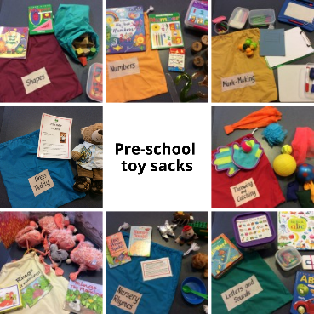
TOY SACKS - This is just a reminder that these are now available to borrow on a weekly basis. Please speak to a member of staff if you would like to take one home. Here is the photo again to remind you what is available.

*Please speak to us if you have any suggestions, comments or concerns regarding Preschool.
Contact numbers - Pre-school landline – 24714 (Pre-school hours only)

