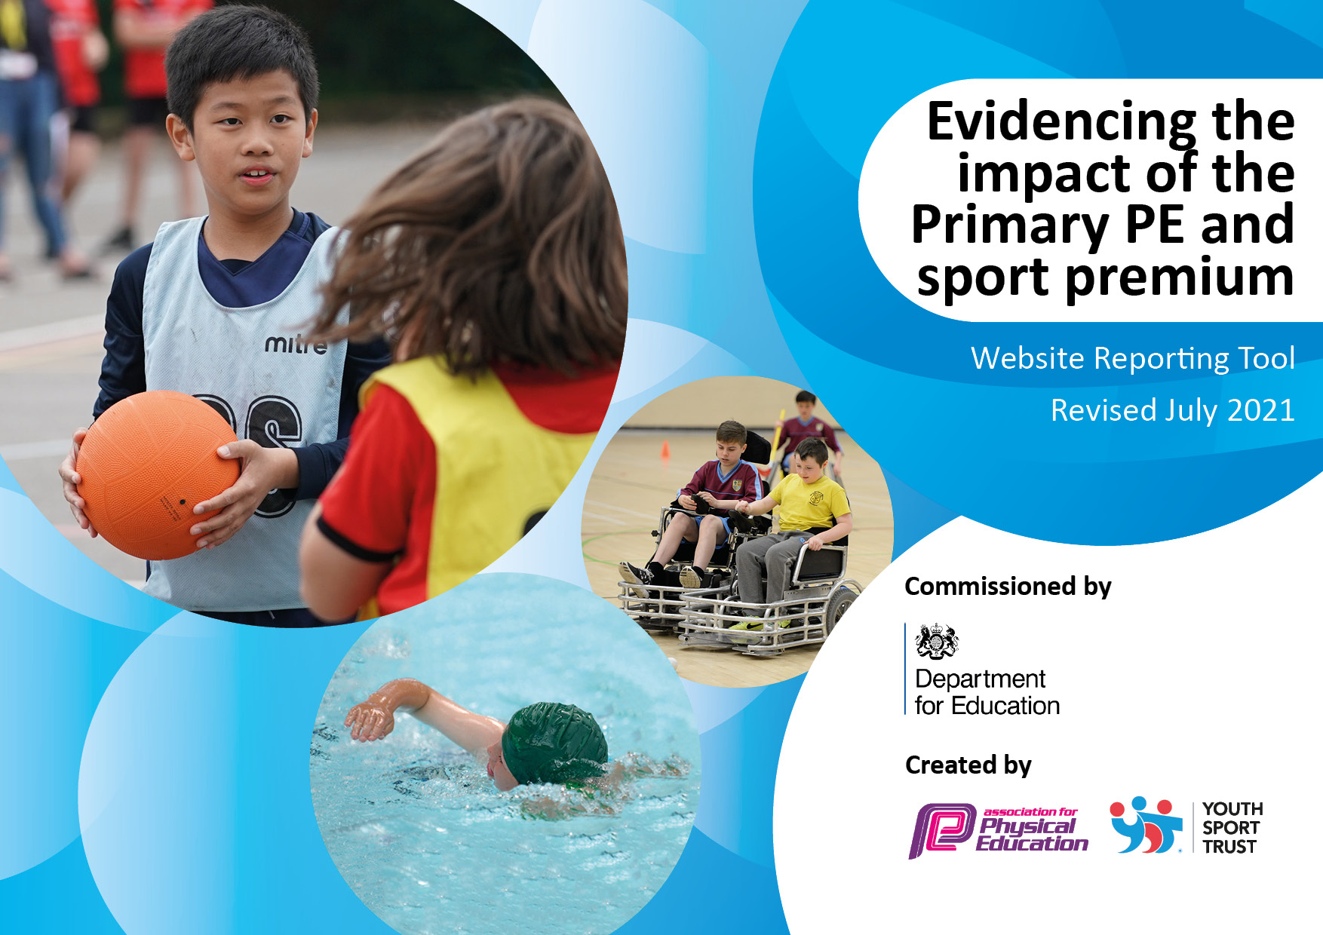
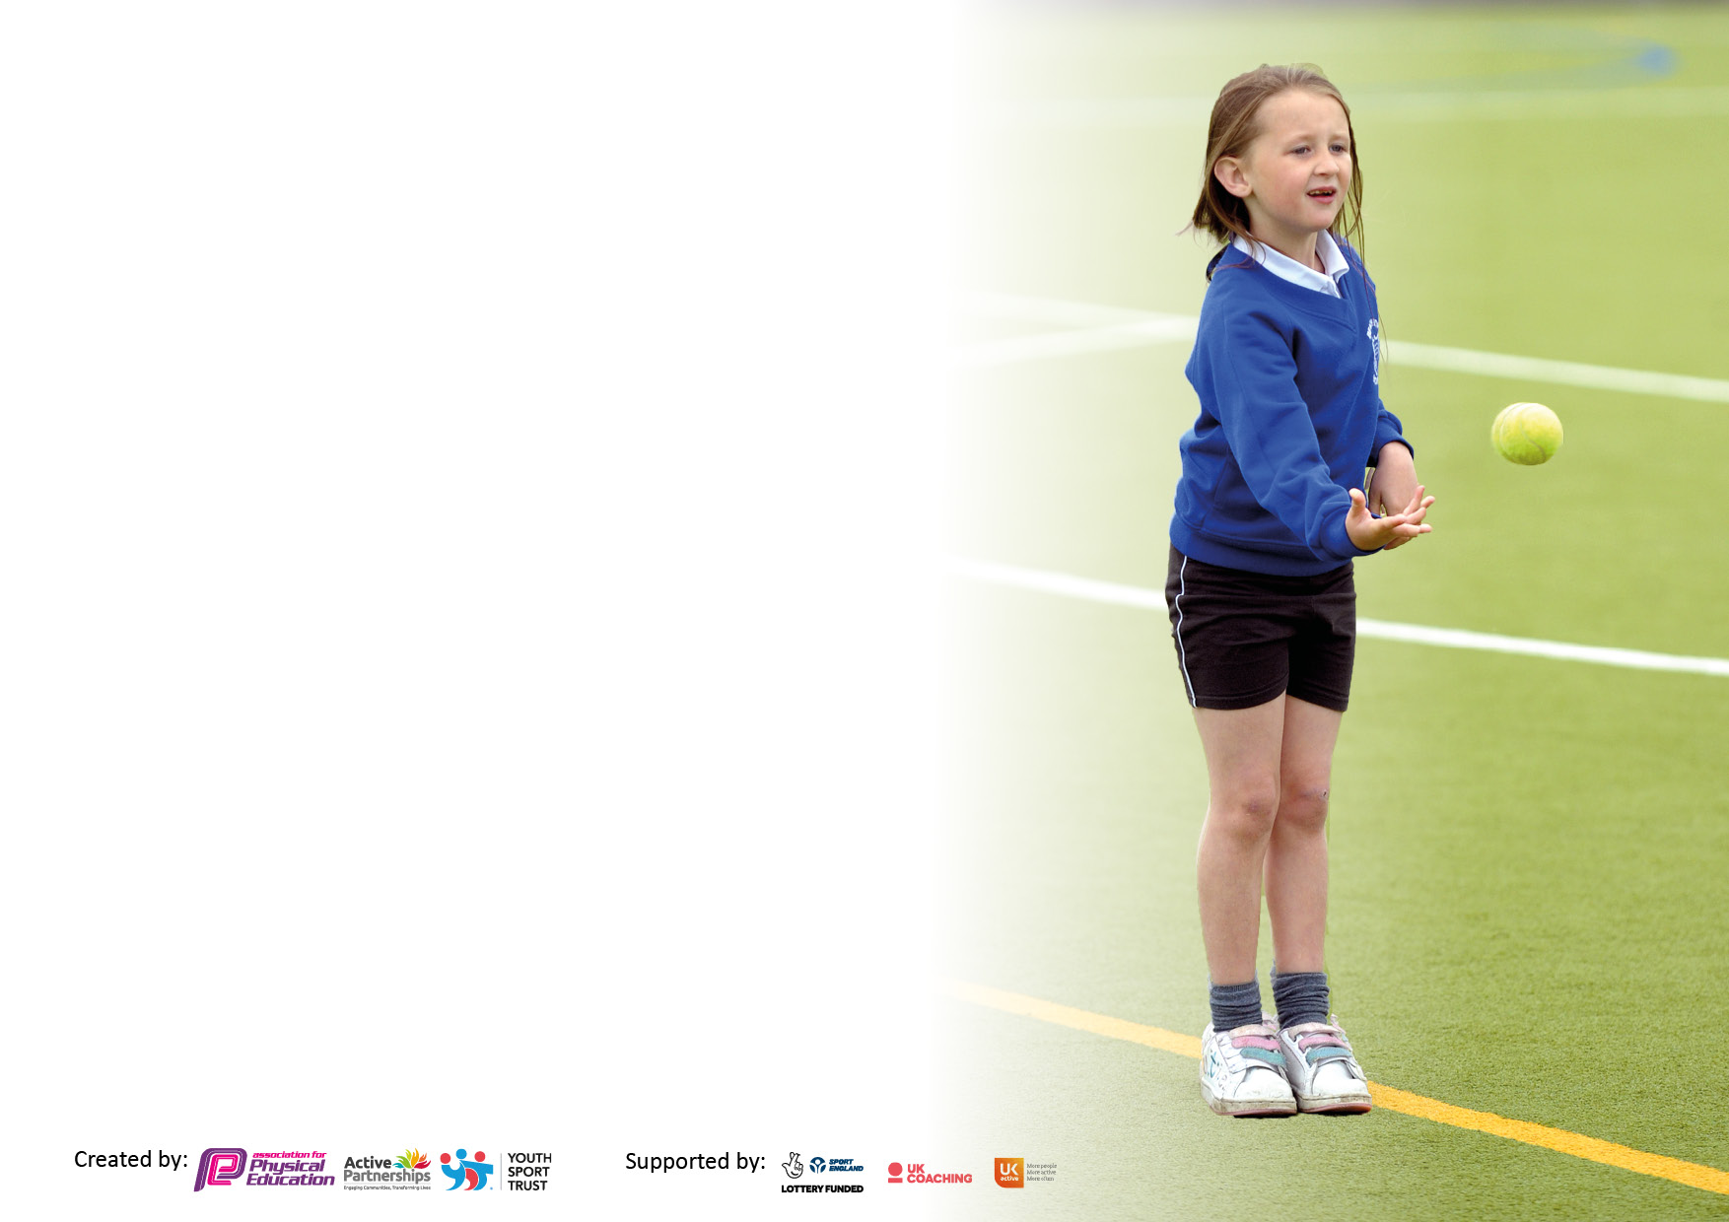

It is important that your grant is used effectively and based on school need. The Education Inspection Framework makes clear there will be a focus on ‘whether leaders and those responsible for governors all understand their respective roles and perform these in a way that enhances the effectiveness of the school’.

Under the Quality of Education Ofsted inspectors consider:
Intent - Curriculum design, coverage and appropriateness
Implementation - Curriculum delivery, Teaching (pedagogy) and Assessment
Impact - Attainment and progress

To assist schools with common transferable language this template has been developed to utilise the same three headings which should make your plans easily transferable between working documents.

Schools must use the funding to make additional and sustainable improvements to the quality of Physical Education, School Sport and Physical Activity (PESSPA) they offer. This means that you should use the Primary PE and sport premium to:

- Develop or add to the PESSPA activities that your school already offer
- Build capacity and capability within the school to ensure that improvements made now will benefit pupils joining the school in future years
- The Primary PE and sport premium should not be used to fund capital spend projects; the school’s budget should fund these.

Pleasevisitgov.ukfortherevisedDfEguidanceincludingthe5keyindicatorsacrosswhichschoolsshoulddemonstrate animprovement.Thisdocumentwillhelpyoutoreviewyourprovisionandtoreportyourspend.DfEencouragesschools to use this template as an effective way of meeting the reporting requirements of the Primary PE and sport premium.

We recommend you start by reflecting on the impact of current provision and reviewing the previous spend.

Schools are required to publish details of how they spend this funding, including any under-spend from 2019/2020, as well as on the impact it has on pupils’ PE and sport participation and attainment. All funding must be spent by 31st July 2023.

We recommend regularly updating the table and publishing it on your website throughout the year. This evidences your ongoing self-evaluation of how you are using the funding to secure maximum, sustainable impact. Final copy must be posted on your website by the end of the academic year and no later than the 31st July 2022. To see an example of how to complete the table please click HERE.
Created by: Supported by:

Swimming Data
Please report on your Swimming Data below.

Meeting national curriculum requirements for swimming and water safety.

N.B. Complete this section to your best ability. For example you might have practised safe self-rescue techniques on dry land which you can then transfer to the pool when school swimming restarts.
Due to exceptional circumstances priority should be given to ensuring that pupils can perform safe self rescue even if they do not fully meet the first two requirements of the NC programme of study
What percentage of your current Year 6 cohort swim competently, confidently and proficiently over a distance of at least 25 metres?
N.B. Even though your pupils may swim in another year please report on their attainment on leaving primary school at the end of the summer term 2021.
Please see note above
What percentage of your current Year 6 cohort use a range of strokes effectively [for example, front crawl, backstroke and breaststroke]?
Please see note above
What percentage of your current Year 6 cohort perform safe self-rescue in different water-based situations?
Schools can choose to use the Primary PE and sport premium to provide additional provision for swimming but this must be for activity over and above the national curriculum requirements. Have you used it in this way?

Action Plan and Budget Tracking
Capture your intended annual spend against the 5 key indicators. Clarify the success criteria and evidence of impact that you intend to measure to evaluate for pupils today and for the future.

Academic Year: 2022/2023 | Total fund allocated: 16,580 | Date Updated: 06/12/2022
Key indicator 1: The engagement of all pupils in regular physical activity – Chief Medical Officers guidelines recommend that primary school pupils undertake at least 30 minutes of physical activity a day in school |  |  |  | Percentage of total allocation:
Intent | Implementation |  | Impact
Your school focus should be clear what you want the pupils to know and be able to do and about  what they need to learn and to  consolidate through practice: | Make sure your actions to achieve are linked to your intentions: | Funding allocated: | Evidence of impact: what do pupils now know and what can they now do? What has changed?: | Sustainability and suggested next steps:
Facilitate and engage all children in daily active playtimes.  Increase number of extracurricular activities available for students.  Facilitate regular high quality PE lessons by PE specialist and school staff for all children across the school. | Playtime equipment has been purchased so all children have access to a range of different physical activities during daily playtimes.  The Sports Leaders programme continues with a team of KS2 children leading activities for all students during PE lessons and play times.  Extra-curricular clubs are available for all children. These are led by external providers as well as class teachers and PE specialist.  High quality and regular PE lesson will engage and keep all children physically active. | £100  No cost  £2000  See KI3  Total:2100

Key indicator 2: The profile of PESSPA being raised across the school as a tool for whole school improvement |  |  |  | Percentage of total allocation:
Intent | Implementation |  | Impact
Your school focus should be clear what you want the pupils to know and be able to do and about  what they need to learn and to  consolidate through practice: | Make sure your actions to achieve are linked to your intentions: | Funding allocated: | Evidence of impact: what do pupils now know and what can they now do? What has changed?: | Sustainability and suggested next steps:
Specialist PE staff to raise profile of PE and school sport to drive forward improvement in the subject and whole school community.  Use PE as a driver for improvements in student learning and behaviour.  Increase sense of community through participation in local and wider PE events.  Increase engagement of children and quality of PE using specialist resources and equipment. | The school has employed the Link Academy specialist PE teacher to work will all children across the school.  The new rolling PE curriculum and planning giving staff the tools to improve the quality of teaching and learning through sport and physical activity.  All children throughout the year will participate in trust-wide and partnership events and festivals.  Purchase of specific PE equipment for each activity included in the PE curriculum. | See KI3  No cost (provided by PE specialist – see KI3)  See KI3  £200  Total: £200

Key indicator 3: Increased confidence, knowledge and skills of all staff in teaching PE and sport |  |  |  | Percentage of total allocation:
Intent | Implementation |  | Impact
Your school focus should be clear | Make sure your actions to | Funding | Evidence of impact: what do | Sustainability and suggested
what you want the pupils to know | achieve are linked to your | allocated: | pupils now know and what | next steps:
and be able to do and about | intentions: |  | can they now do? What has
what they need to learn and to |  |  | changed?:
consolidate through practice:
Regular professional development for all teaching staff, promoting higher quality teaching of PE.  Increased confidence and knowledge of teaching PE through the use of the PE curriculum and schemes of work.  Increased knowledge and confidence in teaching specific PE sports and activities. | Employed school PE teacher to deliver regular training for staff.  Class teachers work with PE specialist to assess students and have regular feedback about their own delivery of PE.  All staff to utilise the provided PE planning and schemes of work to increase their knowledge and confidence in the subject.  Termly organised bespoke PE delivery CPD made available to all staff. Delivered by the Trust PE specialist team. | £10,007  No cost  No cost  Total: £10,007

Key indicator 4: Broader experience of a range of sports and activities offered to all pupils |  |  |  | Percentage of total allocation:
Intent | Implementation |  | Impact
Your school focus should be clear | Make sure your actions to | Funding | Evidence of impact: what do | Sustainability and suggested
what you want the pupils to know | achieve are linked to your | allocated: | pupils now know and what | next steps:
and be able to do and about | intentions: |  | can they now do? What has
what they need to learn and to |  |  | changed?:
consolidate through practice:
All children to be taught and experience a wide range of sports and activities during PE lesson.  All children to experience at least one day trip out at an external adventure provider.  Transport to and from sporting events.  Continue to develop sports leadership opportunities for a team of KS2 children.  Provide all children the opportunity to experience a range of different activities during annual Sports Enrichment Day.  . | Staff and PE specialist to deliver the rolling PE curriculum.  Organise and book day trips for different year groups and classes  Book coaches to transport children to and from sporting events across the year.  Order new sports leaders tops and additional equipment.  Whole-school sport enrichment day planned for the summer term. | No cost  £1000  £2000  £100  £500  Total: £3600

Key indicator 5: Increased participation in competitive sport |  |  |  | Percentage of total allocation:
Intent | Implementation |  | Impact
Your school focus should be clear | Make sure your actions to | Funding | Evidence of impact: what do | Sustainability and suggested
what you want the pupils to know | achieve are linked to your | allocated: | pupils now know and what | next steps:
and be able to do and about | intentions: |  | can they now do? What has
what they need to learn and to |  |  | changed?:
consolidate through practice:
Offer all children the chance to access trust-wide competitions and events to compete.  Introduce a range of new sports and activities to encourage children to be competitive during PE lessons.  Introduce a range of new sports and activities to encourage children to be competitive during after school clubs. | Throughout the year all children will have the opportunity to go and take part in Trust organised competitive events. Tag rugby Autumn term 1.  PE specialist to continue to teach a variety of competitive sports during PE lesson for all children.  PE specialist to continue to teach a variety of competitive sports during KS1 and 2 after school clubs. | No cost  No cost  No cost  Total: £15907

Total Funding Projected spend: £15907

Signed off by
Head Teacher:
Date:
Subject Leader: | Sam Luxa
Date:
Governor:
Date:

