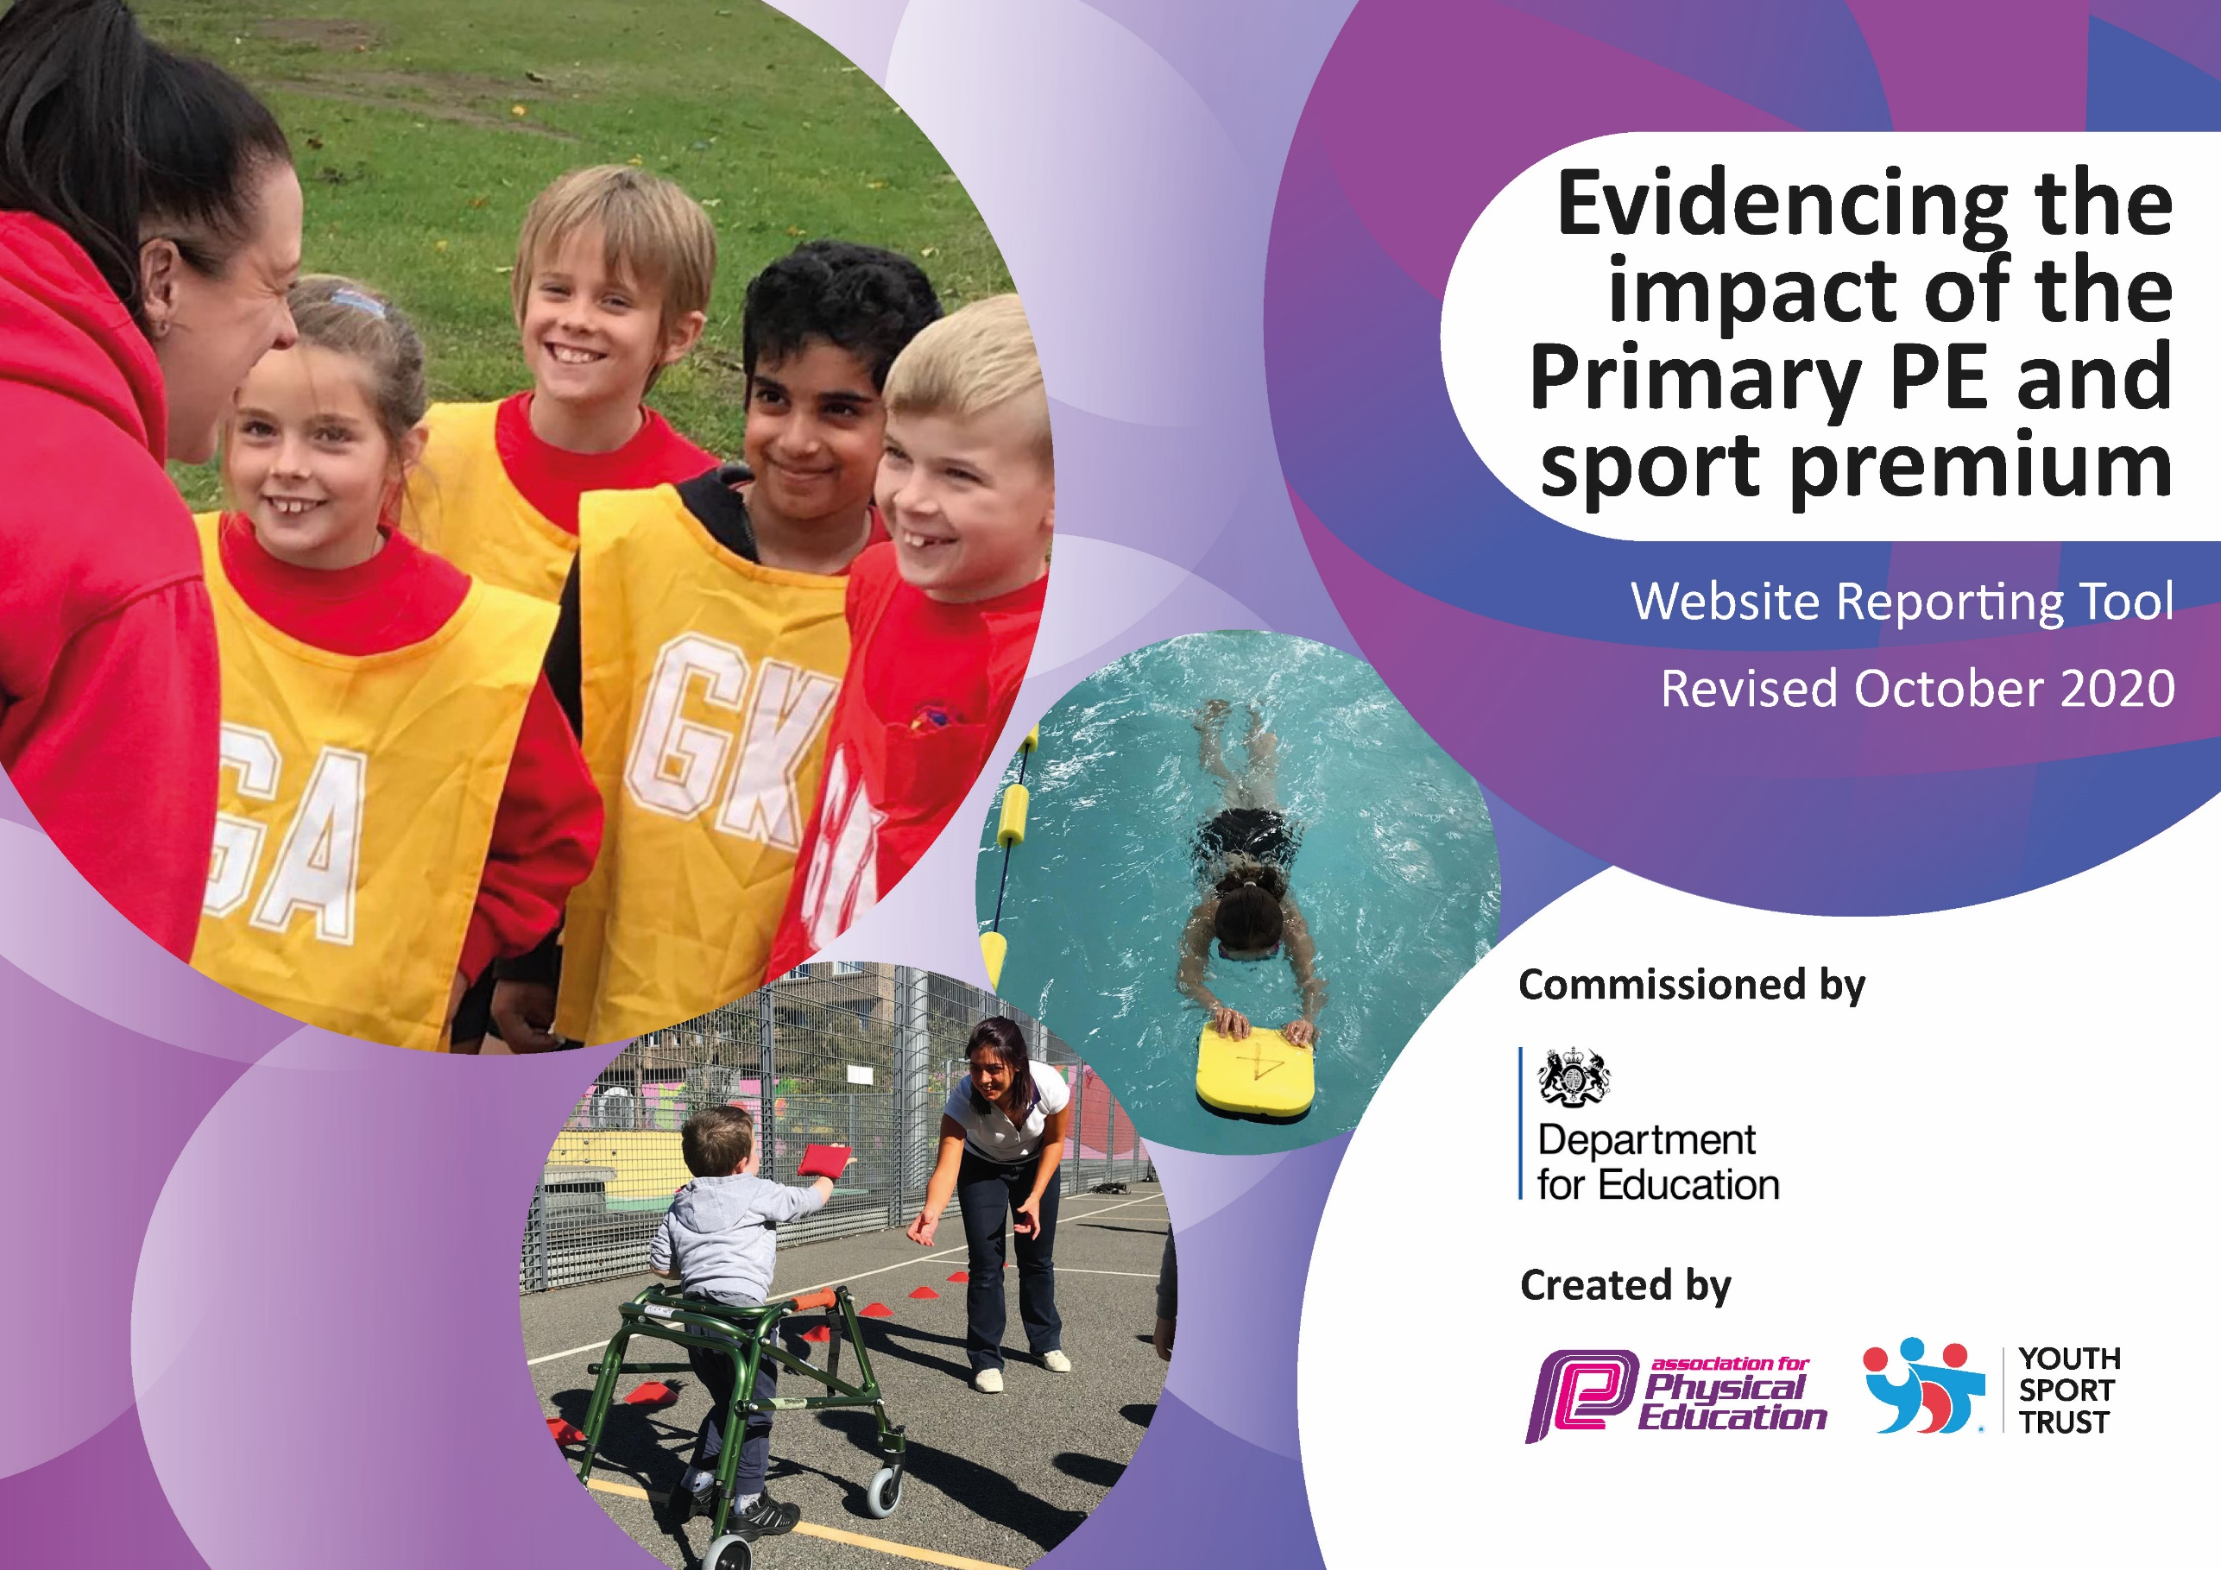
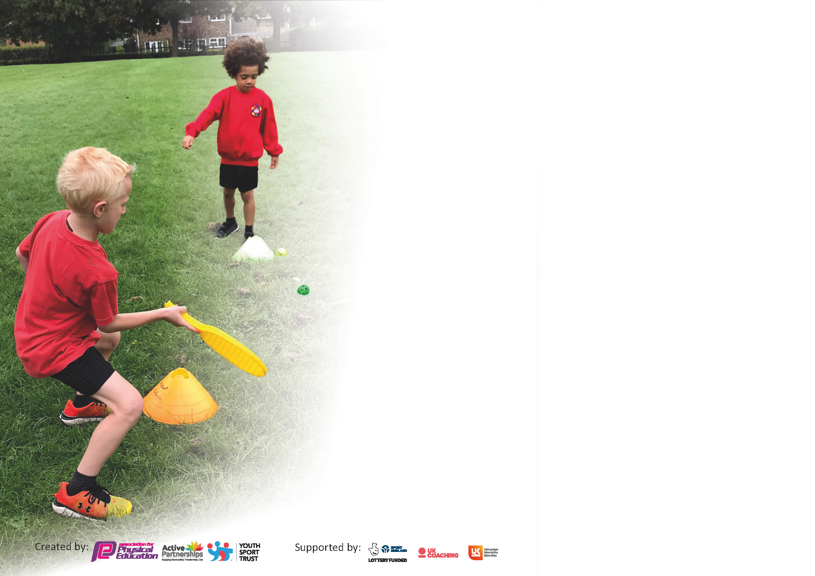

It is important that your grant is used effectively and based on school need. The Education Inspection Framework (Ofsted 2019 p64) makes clear there will be a focus on ‘whether leaders and those responsible for governors all understand their respective roles and perform these in a way that enhances the effectiveness of the school’.

Under the Quality of Education criteria (p41) inspectors consider the extent to which schools can articulate their curriculum (INTENT), construct their curriculum (IMPLEMENTATION) and demonstrate the outcomes which result (IMPACT).

To assist schools with common transferable language this template has been developed to utilise the same three headings which should make your plans easily transferable between working documents.

Schools must use the funding to make additional and sustainable improvements to the quality of Physical Education, School Sport and Physical Activity (PESSPA) they offer. This means that you should use
the Primary PE and sport premium to:

- Develop or add to the PESSPA activities that your school already offer
- Build capacity and capability within the school to ensure that improvements made now will benefit pupils joining the school in future years

Please visit gov.uk for the revised DfE guidance including the 5 key indicators across which schools should demonstrate an improvement. This document will help you to review your
provision and to report your spend. DfE encourages schools to use this template as an effective way of meeting the reporting requirements of the Primary PE and sport premium.

We recommend you start by reflecting on the impact of current provision and reviewing the previous spend.

Schools are required to publish details of how they spend this funding as well as on the impact it has on pupils’ PE and sport participation and attainment by the end of the summer term or by 31st July 2022 at the latest.

** In the case of any under-spend from 2020/21 which has been carried over this must be used and published by 31st March 2022.

We recommend regularly updating the table and publishing it on your website throughout the year. This evidences your ongoing self-evaluation of how you are using the funding to secure maximum, sustainable impact. Final copy must
be posted on your website by the end of the academic year and no later than the 31st July 2022. To see an example of how to complete the table please click HERE.
Created by: Supported by:

Please note: Although there has been considerable disruption in 2021 it is important that you publish details on your website of how you spend the funding - this is a legal requirement.
Support for review and reflection - considering the 5 key indicators from DfE, what development needs are a priority for your setting and your pupils now and why? Use the space below to reflect on previous spend and key achievements and areas for development.

N.B. In this section you should refer to any adjustments you might have made due to Covid-19 and how these will influence further improvement.
Key achievements to date until July 2021: | Areas for further improvement and baseline evidence of need:
KI1  - All children given 60 minutes of physical activity through constructive Play Leader lead lunchtimes activities and whole-school morning movement activities.  - All children given 2 hours of PE per week. 1 hour of which with the Trust employed PE specialist.  KI2  - Trust employed PE specialist to lead subject within the school.  - Profile of PE raised across the school through a wide range of curricular opportunities and extra-curricular clubs for all students.  - Use of video analysis in line with whole school improvement plan.  KI3  - Staff confidence and ability to teach PE improved by working closely with PE specialist throughout the year.  - CPD has been provided for all teaching staff and has improved staff confidence of delivering a range of PE activities.  KI4  - New PE curriculum has been rolled out, which includes a greater range of sports and activities, increasing the opportunity for all children.  - Wide variety of extra-curricular opportunities available for all children to widen their experiences.  - Whole-school community day to provide wider variety of activities.  KI5  - Despite difficulties surrounding COVID-19 restrictions, all children in KS1 & 2 have taken part in a competitive virtual festival against other schools.  - All children given the opportunity to take part in competitive activities during PE lessons and extra curricular clubs. | - Additional festivals for KS1, KS2 and EYFS (COVID permitting). This will allow all children in the school to take part in competitive activity (KI 5). These festivals were planned but could not take place due to COVID-19.  - Wider opportunities for children to take part in outdoor and adventurous activities/gain experiences outside of the school in areas which are not covered in the PE curriculum e.g. rock climbing, sailing etc.  - Continued communication and collaboration between all teaching staff and PE specialist to continue to build the profile and quality of PE within the whole school.

Did you carry forward an underspend from 2020-21 academic year into the current academic year?

If YES you must complete the following section
If NO, the following section is not applicable to you

If any funding from the academic year 2020/21 has been carried over you MUST complete the following section. Any carried over funding MUST be spent by 31 March 2022.

Sports Premium Carry-Over

Academic Year: September 2021 to March 2022 | Total fund carried over: | Date Updated:
What Key indicator(s) are you going to focus on?  KI1, 2 and 4. |  |  |  | Total Carry Over Funding:
Intent | Implementation |  | Impact

Meeting national curriculum requirements for swimming and water safety.

N.B Complete this section to your best ability. For example, you might have practised safe self-rescue techniques on dry land.
What percentage of your current Year 6 cohort swim competently, confidently and proficiently over a distance of at least 25 metres?  N.B. Even though your pupils may swim in another year please report on their attainment on leaving primary school at the end of the summer term 2021. | %  N/A as swimming provision has been effected by COVID-19 restrictions.
What percentage of your current Year 6 cohort use a range of strokes effectively [for example, front crawl, backstroke and breaststroke]? | %  N/A as swimming provision has been effected by COVID-19 restrictions.
What percentage of your current Year 6 cohort perform safe self-rescue in different water-based situations? | %  N/A as swimming provision has been effected by COVID-19 restrictions.
Schools can choose to use the Primary PE and sport premium to provide additional provision for swimming but this must be for activity over and above the national curriculum requirements. Have you used it in this way? | No

Action Plan and Budget Tracking
Capture your intended annual spend against the 5 key indicators. Clarify the success criteria and evidence of impact that you intend to measure to evaluate for pupils today and for the future.

Academic Year: 2020/21 | Total fund allocated: £16,900 | Date Updated: 23/06/2021
Key indicator 1: The engagement of all pupils in regular physical activity – Chief Medical Officers guidelines recommend that primary school pupils undertake at least 30 minutes of physical activity a day in school |  |  |  | Percentage of total allocation:
Intent | Implementation |  | Impact
Your school focus should be clear what you want the pupils to know and be able to do and about  what they need to learn and to  consolidate through practice: | Make sure your actions to achieve are linked to your intentions: | Funding allocated: | Evidence of impact: what do pupils now know and what can they now do? What has changed?: | Sustainability and suggested next steps:
Facilitate and engage all children in daily active playtimes.  All children participate in the Daily Mile at the beginning of each day for additional physical activity.  Increase number of extracurricular activities available for students | Playtime equipment has been purchased so all children have access to a range of different physical activities during daily playtimes.  The Sports Leaders programme continues with a team of KS2 children leading activities for all students during PE lessons and play times.  We continue to participate in the Daily Mile which we have set up. All classes participate each day to increase their physical activity.  Extra-curricular clubs are available for all children. These are led by external providers as well as class teachers and PE specialist. | £500  No cost  No cost
All children take part in a weekly active assembly with PE specialist. | Once a week the PE specialist will take the active assembly for the whole school and lead a wide variety of physical activities. | TOTAL £500

Key indicator 2: The profile of PESSPA being raised across the school as a tool for whole school improvement |  |  |  | Percentage of total allocation:
Intent | Implementation |  | Impact
Your school focus should be clear what you want the pupils to know and be able to do and about  what they need to learn and to  consolidate through practice: | Make sure your actions to achieve are linked to your intentions: | Funding allocated: | Evidence of impact: what do pupils now know and what can they now do? What has changed?: | Sustainability and suggested next steps:
Specialist PE staff to raise profile of PE and school sport to drive forward improvement in the subject and whole school community.  Use PE as a driver for improvements in student learning and behaviour.  Increase sense of community through participation in local and wider PE events.  Increase engagement of children and quality of PE using specialist resources and equipment.  Develop PE in line with whole-school improvement plan - Give students access to greater ICT and video analysis opportunity to develop their learning. | The school has continue the employment a specialist PE teacher.  The new rolling PE curriculum and planning giving staff the tools to improve the quality of teaching and learning through sport and physical activity.  All children throughout the year will participate in trust-wide and partnership events and festivals.  Purchase of specific PE equipment for each activity included in the PE curriculum. (Basketball hoop and rebounders). | See KI3  No cost (provided by PE specialist – see KI3)  See KI3  £1500  Total: £1500

Key indicator 3: Increased confidence, knowledge and skills of all staff in teaching PE and sport |  |  |  | Percentage of total allocation:
Intent | Implementation |  | Impact
Your school focus should be clear  what you want the pupils to know  and be able to do and about  what they need to learn and to  consolidate through practice: | Make sure your actions to  achieve are linked to your  intentions: | Funding  allocated:
Regular professional development for all teaching staff, promoting higher quality teaching of PE.  Increased confidence and knowledge of teaching PE through the use of the PE curriculum and schemes of work.  Increased knowledge and confidence in teaching specific PE sports and activities. | Employed school PE teacher to deliver regular training for staff.  Class teachers work with PE specialist to assess students and have regular feedback about their own delivery of PE.  All staff to utilise the provided PE planning and schemes of work to increase their knowledge and confidence in the subject.  Termly organised bespoke PE delivery CPD made available to all staff. Delivered by the Trust PE specialist team. | £9025  No cost  No cost  Total: £9025

Key indicator 4: Broader experience of a range of sports and activities offered to all pupils |  |  |  | Percentage of total allocation:
Intent | Implementation |  | Impact
Your school focus should be clear | Make sure your actions to | Funding | Evidence of impact: what do | Sustainability and suggested
what you want the pupils to know | achieve are linked to your | allocated: | pupils now know and what | next steps:
and be able to do and about | intentions: |  | can they now do? What has
what they need to learn and to |  |  | changed?:
consolidate through practice:
All children continue to be taught and experience a wide range of sports and activities during PE lesson.  Continue to develop sports leadership opportunities for a team of KS2 children.  Fund KS2 residential activities school trip.  When restrictions allow, use specialist providers to offer students exciting activities and enrichment opportunities.  All children throughout the year will have access to afterschool sports clubs.  Funds available for coach hire and additional travel cost to allow children to access fixtures, festival and enrichment away from school. | Staff and PE specialist to continue to deliver the rolling PE curriculum.  Order new sports leaders tops, badges and additional equipment.  Plan and book residential including travel and accommodation.  Whole-school sport enrichment day planned for the summer term.  PE specialist to continue to run KS1 and KS2 sports clubs teaching a wide variety of sports and activities.  Book coaches and mini buses when and where required. | No cost  £250  £1500  £1000  No cost  £1000  Total: £3750

Key indicator 5: Increased participation in competitive sport |  |  |  | Percentage of total allocation:
Intent | Implementation |  | Impact
Your school focus should be clear | Make sure your actions to | Funding | Evidence of impact: what do | Sustainability and suggested
what you want the pupils to know | achieve are linked to your | allocated: | pupils now know and what | next steps:
and be able to do and about | intentions: |  | can they now do? What has
what they need to learn and to |  |  | changed?:
consolidate through practice:
Offer all children the chance to access trust-wide competitions and events to compete. | Throughout the year all children will have the opportunity to go and take part in Trust organised competitive events. Tag rugby Autumn term 1. | No cost
Introduce a range of new sports and activities to encourage children to take up and compete in competitive sports. | Sign up and book dates with QEAT Sports Partnership Programme. | £600
Introduce a range of new sports and activities to encourage children to be competitive during PE lessons. | PE specialist to continue to teach a variety of competitive sports during PE lesson for all children. | No cost
Introduce a range of new sports and activities to encourage children to be competitive during after school clubs. | PE specialist to continue to teach a variety of competitive sports during KS1 and 2 after school clubs. | No cost  Total: £600  Total: 15,375

Total Allocation: 16,900
Total spent: 16,900

Signed off by
Head Teacher: | Robin Scott
Date: | Sept 2021
Subject Leader: | Nicola Miners
Date: | Sept 2021
Governor: | Jo Carter
Date: | Sept 2021

