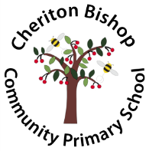

*MATHEMATICS CURRICULUM*

*STATEMENT*

At Cheriton Bishop and Yeoford Primary School, we are passionate about the high-quality teaching of mathematics and understand that the skills that we teach our children will be integral to all aspects of life. With this in mind, we endeavour to make sure that our children develop a healthy and enthusiastic attitude towards mathematics with our ultimate aim for all of our children to be resilient, positive and articulate learners.

Intent

We strongly believe that maths is a journey which is achieved through exploration, practice and application over time. At each stage of learning, we encourage our children to be able to demonstrate deep and conceptual understanding of a topic and then this is able to be built on as the children progress. Through our Multi Academy Trust school research and our study as part of the Jurassic Maths Hub, we understand that there are 3 levels of learning:

Shallow learning: surface, temporary, often lost

Deep learning: It sticks, can be recalled and used

Deepest learning: Can be transferred and applied in different contexts.

It is the intent of our Mathematics curriculum to teach a rich, engaging and balanced programme, which is aimed at children understanding at a deep and deepest level. Through this, the children will develop resilience and self confidence when faced with mathematical challenges and truly believe in themselves as mathematicians. We understand the importance of teaching the children to embrace making mistakes as part of the learning process and value the importance of effort.

It is our absolute priority during maths sessions that children are engaged, enthused and make good progress over time. Our focus on QFT (Quality First Teaching) ensures that we have high expectations and that all children (including SEND, PP and the lowest 20%,) are supported, when appropriate, to access not only our Maths curriculum but our full and rich curriculum.

Implementation

At Cheriton Bishop and Yeoford Primary School, we ensure that our children have access to a high quality Maths curriculum that is both challenging and enjoyable. Objects, pictures, words, numbers and symbols are displayed in each class and form part of the learning environment, which supports our approach to teaching mastery. We keep the connective model at the heart of the learning experiences for our children. We believe this helps them to explore and demonstrate mathematical ideas, enrich their learning experience and deepen their understanding. Together, these elements help cement knowledge so pupils truly understand what they have learnt.

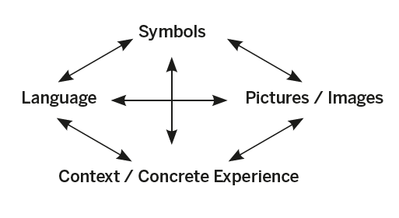

The connective model, Haylock and Cockburn (1989)

Short term planning makes use of the Rising stars, White Rose Maths Hub, NCETM and NRICH resources. We also have our own school Calculation Policy and Curriculum Plan. The Calculation Policy and Curriculum Plan are used to ensure there is a consistent approach to mathematics as the children move from class to class. In each class, we understand the vital role that fluency plays in developing mathematical understanding. Therefore, all children receive 15 minutes of basic skills to help develop fluency which follows the ‘No Nonsense Maths’ guide. This may include discussion, pre teaching and extending vocabulary.

In maths sessions, each unit of mathematics is taught in a sequence which has been planned based on formative assessment of what the children already know. Elicitation tasks are carefully designed by the teachers at the start of every unit to inform the planning cycle. New content is taught through small steps to support children in their learning journey which then progresses into supported, independent practise for children to secure their new skills. Teachers use differentiated questioning to elicit feedback from all students to identify and address any misconceptions in learning. Where these misconceptions are seen, they are readdressed through supported practice to enable all children to succeed. There is a focus on breadth and depth of understanding within our curriculum and children are encouraged to apply their knowledge in a range of scenarios. This may be in other areas of the curriculum or, where possible, in real life situations. We believe it to be of absolute importance that the children understand where Maths fits as part of the wider world.

We believe that our planning ensures that we develop independent learners with inquisitive minds who have secure mathematical foundations.

Impact

We recognise that through the study of mathematics, we are equipping our children with a uniquely powerful set of tools to understand the world around them. These tools include reasoning, problem solving and the ability to think in abstract ways. We believe that these skills are not only important at this stage in their life, but will be carried with them for the rest of their lives. Whether this be in their future careers, learning to drive or simply navigating their way through daily life, we envisage that these tools will contribute towards our children becoming happy, healthy, successful adults. For our children in our schools, we hope that the impact of our curriculum is that we create well rounded learners. Learners that are not afraid of making mistakes; learners that are able to ‘think around a problem’ showing resilience and strength; learners that have a secure knowledge and understanding but most importantly of all, learners that enjoy learning and strive to be the best that they can be.

The Curriculum Leader for Mathematics is: Mrs Vicki Gillon

|  |
| --- |
| Mathematics in the Early Years:  In our schools we provide children with opportunities to develop and improve their skills in counting, understanding and using numbers, calculating simple addition and subtraction problems; and to describe shapes, spaces, and measure. Activities are based on practical real-life contexts to encourage inquisitive minds and develop critical thinking  Number: children count reliably with numbers from 1 to 20, place them in order and say which number is one more or one less than a given number. Using quantities and objects, they add and subtract two single-digit numbers and count on or back to find the answer. They solve problems, including doubling, halving and sharing.  Shape, Space and Measure: children use everyday language to talk about size, weight, capacity, position, distance, time and money to compare quantities and objects and to solve problems. They recognise, create and describe patterns. They explore characteristics of everyday objects and shapes and use mathematical language to describe them. |