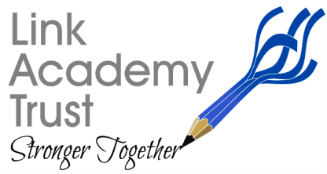
Cheriton Bishop Primary School
Church Lane, Cheriton Bishop, Exeter, Devon. EX6 6HY Tel: 01647 24817
Email: admincheritonbishop@thelink.academy

12th February 2021

Dear Parents/Carers,

Many thanks to everyone who gave their time to answer our parent’s survey regarding remote learning. It was lovely to have such positive affirmations of the work being done by the staff. I’d like to share a few of the things we have learnt and a few tweaks we will be making to ensure everything is as good as it can be for your children.

We have learnt:
- Pupil engagement is high
- 88% of parents feel school is setting the right amount of work with 6% feeling too little and 6% feeling too much.
- Remote learning is going well and live lessons help your children to feel connected and to engage better in learning.
- Recorded lessons with clear concise instructions make it easier for parents and children to access learning.
- You value having the teacher’s voice in the home. Teachers leading learning is a significant positive. We are grateful for these comments as live and recorded lessons take significantly longer to plan and put together for online access.
- When we run separate lessons for different groups, you value this as you are aware that this enables specific access to specific content. It also allows a smaller group of children to interact. We are using staff as much as possible to provide this.
- We are aware that some parent groups are using their own platforms, monitored by them, for socialising - which is great news.
What will we do next?
- We will continue to work closely with the Internet providers to try to resolve and improve issues around bandwidth. This is being fully explored by Limtec and Matt Matthews, the Business Manager.
- We will remind parents that they can contact teachers daily by emailing the office and marking with the teacher’s name. Teacher’s will endeavor to get back to you on the same day.
- As most parents are happy with the amount of work set, we will guide those who would like more towards the BBC/Oak Academy materials.
- We will be attending more training and continue to develop the use of 'OneNote' and where appropriate ‘Assignments’ through Teams.
- We will try to be available for more 1:1 catch ups with pupils, however this is extremely time consuming and can only be achieved if staffing ratios allow.
- The school will try to set up a class online get-together at a set time (like a lunchtime), subject to staff availability

I would like to add to this that I am aware that we continue to ask for full engagement to enable children to maintain their learning but we understand that everyone has different constraints and calls on their time. Please be reassured that we value what you are doing and know that you are doing your very best. If you need to talk to class teachers about home learning, please do. We are here to support both your children and you.

Our Improvement and Inclusion Hub are also there to support you should you need it. Please see poster below.

Many thanks for your continuing support,

Mrs Alex Waterman – Executive Academy Head

