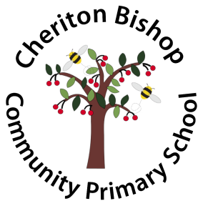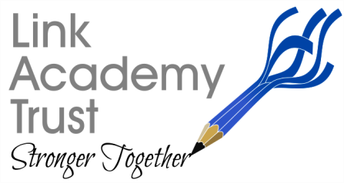

**The Link Academy Trust Strategic Improvement Priorities**

**KEY IMPROVEMENT PRIORITIES for 2021 - 2022**

**CHERITON BISHOP**

**Key Priority 1**

**Wellbeing**

Staff, pupils and family’s well-being remains central to decisions made. Every pupil, family and staff member across the school are well supported.

Staff are well supported; their workload is managed; they have access to CPD opportunities as well as the ability to follow the Trusts career pathways and the leadership opportunities it presents across the trust.

**Key Priority 3**

**Literacy**

Further develop the quality of writing by supporting children to forensically analyse and improve their own work.

Offer a wide range of opportunities for children to write across the curriculum adding interest, purpose and a real audience.

**Key Priority 3**

**Global Awareness**

Develop the children’s awareness and understanding of global issues and encourage them to be outward facing and develop attitudes of ‘global generosity’.

**Key Priority 6**

**Vocabulary**

Vocabulary and Oracy Skills are developed in a progressive way.

Children are aware of and understand key vocabulary which allow them to access the curriculum

**Key Priority 2**

**Curriculum**

The children engage in a broad and balanced curriculum.

Leaders and Subject Leaders know their subject areas. Each area contains a well-planned progression of skills and staff can articulate the intent, implementation and impact this has on the children’s progress.

**Key Priority 4**

**Maths**

Further develop and embed a cohesive approach to the learning and teaching within maths across the school.

Children make the expected rate of progress and dive deeper into their learning within a challenging curriculum**.**