Cheriton Bishop Primary School
Writing Curriculum Statement
Writing
Our core purpose is for children to develop a love for writing and become independent, fluent writers who cultivate personal style throughout their time in school. Through the design of our curriculum, underpinned by the principles of ‘Talk for Writing’ and Babcock Texts that Teach, we aim to create a writing culture where children: see themselves as writers; become inspired by high quality texts and authors; apply rich and varied vocabular discerningly; edit with skill, accuracy and purpose; develop stamina and resilience; are ready for their next stage in learning. With clarity of purpose and audience, we structure the teaching of writing progressively and sequentially in order that pupils see and reflect on their progress from elicitation to final piece. We celebrate writing!

A writer at our school will:
- Take pride in their writing and presentation
- Reflect on the use of language to write with purpose and effect
- Consider author voice and intent through shared, quality texts
- Articulate and talk their writing confidently
- Select vocabulary deliberately
- Adjust writing appropriately to a range of genres and across the curriculum
- Apply spelling, punctuation and grammar conventions accurately and independently
- Respond effectively to feedback, co-construct and take ownership of writing targets
- Take risks to write creatively

Vocabulary

Children’s command of vocabulary is fundamental to learning and progress across the curriculum. Vocabulary is developed actively, building systematically on pupil’s current knowledge and deepening their understanding of etymology and morphology (word origins and structures) to increase their store of words. Simultaneously, pupils make links between known and new vocabulary, and discuss and apply shades of meaning. In this way, children expand the vocabulary choices that are available to them. It is essential to introduce technical vocabulary which define each curriculum subject. Vocabulary development is underpinned by an oracy culture and a tiered approach. High value is placed on the conscious, purposeful selection of well-chosen vocabulary and appropriate sentence structure to enrich access to learning and feed into written work across the curriculum.
English sequences  At Cheriton Bishop, we use the shared language of ‘English Essentials’ which is a seven-part sequence underpinned by the principles of Talk for Writing. This Sequence starts with an independent writing task to generate targets and ends in a write for purpose. Each sequence lasts from 2-3 weeks and is centred around a quality text. These are selected primarily to address focused learning needs, including SPaG but should be engaging and ‘hook’ pupils into learning. | Target setting  Targets are set in a number of ways. Cohort-based targets identify focused teaching and learning within the next sequence of English. This can be found on the English Working wall. Personal targets identify specific gaps in learning – the ‘thing’ that will moving their learning on next. Children are encouraged to take ownership of these, and they can be found in children’s pencil cases. They are updated regularly through teacher/pupil collaboration and conferencing. | Guided Writing (GW)  Guided writing is the time where the teacher really gets to unpick and move children’s learning on. Children will work in a focused way on specific learning outcomes or targets. GW may be undertaken as a whole class, in small groups or at times individually based on need and context. GW may also be used to address year-group specific learning within our mixed classes. | Shared writing (SW)  Teachers and children collaborate to unpick the text used in the teaching sequence. They may look at specific features, such as: author intent, vocabulary choices, grammatical devices, shades of meaning, composition, effect and impact of writing on the reader. They rehearse ‘writing as a reader’ so that they can ‘read as a writer’.
Vocabulary  We use Beck’s tiered approach and the frayer model as a strategy to learn and explore new, more ambitious vocabulary. It helps to define, understand and contextualise new vocabulary in order to then apply it to their writing. Key vocabulary is identified in teacher’s planning. | Progression in editing  We take a meticulous approach to editing, ensuring that we teach specific editing skills visibly and progressively, alongside SPAG and vocabulary expectations. Pupils develop independence in editing in an age (or stage) appropriate way. We aim to ‘live’ edit as much as possible to catch misconceptions in the writing moment. | Writing across the curriculum  Writing is not restricted to English lessons or writing books. You should expect to see good quality writing across all curriculum subjects where standards and expectations of writing are the same as in English lessons. Evidence can then be gathered from a wide range of sources. | Feedback and marking  Feedback is given verbally and in written form, based on visible learning. It is timely and designed to move learning on at speed. All feedback is designed to support and underpin independent learning. Conferencing is used as a tool to support individual pupil progress.
SPaG  Spelling, punctuation and grammar is taught with the support of ‘No Nonsense’ spelling and grammar. This supports a progressive approach particularly within our mixed-age classes. Our progression by year group document enables us to deliver year group specific content within our mixed aged classes. Application of phonics is a key feature of early spelling. | Purpose for writing  Writing with purpose is an essential part of teaching and learning. Giving pupils an authentic audience and clear purpose, such as to express, persuade or entertain, helps to develop motivation and skill. At the end of each sequence, all children have the opportunity to photocopy their work and take it home. | Interventions  Intervention is used when pupils need further support as identified by ongoing assessment. Specific interventions may include IDL and/or support relevant to achieve individual targets. Conferencing is used as a tool to support individual pupil progress. | Handwriting  Handwriting is taught progressively through Kinetic Letters to support the development of a joined, neat handwriting style. This is introduced from EYFS, where children are encouraged to develop core strength so they are ‘ready to write’. Handwriting is taught alongside spellings to aid retention through muscle memory.
Assessment - in order to assess impact
Children talk positively about writing; editing and improving confidently to achieve quality outcomes. | By investigating high quality, engaging texts, children understand what it means to be a writer and how to appeal to the right audience. They apply their ever growing vocabulary, grammatical patterns and ideas in their writing. | Writing is taught progressively and covers National Curriculum objectives. English NC appendices and our ‘writing progression’ document support a structured approach to ensure that learning makes sense to pupils and builds on their skills. | Attainment is measured using the statutory tests in Year 2 and Year 6. Each year, children are expected to have made good progress and meet ARE. Some will achieve greater depth and those not meeting ARE will receive specific intervention.
Assessment evidence - a guide
EYFS  Observations of writing behaviour including through Tapestry.  Talking to pupils and parents.  Writing books/evidence  Running records to assess fluency and accuracy  Ongoing phonics assessments and checks for application to segmenting to spell. | KS1  Statutory writing evidence for Year 2 SATS - evidence gathering grids (Babcock)  SIMs – in-house data and progress tracking  Teacher assessment - observations of writing behaviour and discussion  English/writing books  Phonics checks  Written responses to activities across the curriculum | Years 3-5  Non-statutory writing evidence gathering grids for moderation (Babcock)  SIMs – in-house data and progress tracking  Teacher assessment - observations of writing behaviour and discussion  English/writing books  Spelling books and weekly tests  Written responses to activities across the curriculum | Year 6  Statutory writing evidence for Year 6 SATs - evidence gathering grids for moderation (Babcock)  SIMs – in-house data and progress tracking  Teacher assessment - observations of writing behaviour and discussion  English/writing books  Spelling books and weekly tests  Written responses to activities across the curriculum

Suggested Texts

Texts will be selected to support the teaching and learning of specific writing skills appropriate to the needs of pupils - links to topic may then be made if the text does so.
Selected texts should ‘hook’ pupils into learning, be engaging and high quality. This list is not definitive and may need supplementing or replacing with alternative units, including to ensure that content is taught in a timely manner
Reception
 | Autumn term |  | Spring term |  | Summer term
SPaG | In Autumn term we expect a basic understanding of the ELGs to:  - Write recognisable letters, most of which are correctly formed  - Spell words by identifying sounds in them and representing the sounds with a letter or letters  - Write simple phrases and sentences that can be read by others. |  | In Spring term we expect an advancing understanding of the ELGs to:  - Write recognisable letters, most of which are correctly formed  - Spell words by identifying sounds in them and representing the sounds with a letter or letters  - Write simple phrases and sentences that can be read by others. |  | In Summer term we expect a deepening understanding of the ELGs to:  - Write recognisable letters, most of which are correctly formed  - Spell words by identifying sounds in them and representing the sounds with a letter or letters  - Write simple phrases and sentences that can be read by others.
 | Retelling traditional tales.  Using new learnt vocabulary from non-fiction books.  Tracing lines and shapes. | Becoming familiar with all Phase 2 sounds and beginning to blend and write simple CVC words.  Retelling new stories from a range of authors.  I can hold a pencil using correct tripod grip. | Write a range of simple phrases using instructional language using some common exception words accurately.  Ask and answer questions about a text.  Use a pencil to begin to accurately form letters. | I can use vocabulary to compare places and people.  Becoming familiar with all Phase 3 sounds and beginning to apply this when writing simple phrases/sentences.  Use a pencil to begin to accurately form letters. | Read and write all phase 3 sounds to write simple sentences.  Use vocabulary to make links between texts and experiences.  Form letters together to make words (on a line). | Working towards writing a coherent sentence that can be read, has fingers spaces, capitals letters and full stops  Using phonological awareness to decode simple texts, answer questions and make predictions based on a text  Accurately form letters to make words and simple sentences.
Year A  Suggested texts | 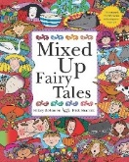  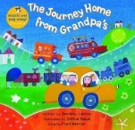 | 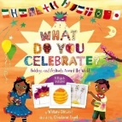  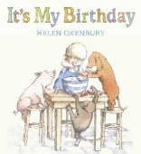 |  | 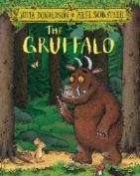 | 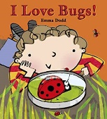  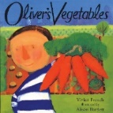 | 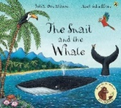  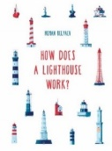
Topic | We’re going on a journey! | Let’s Celebrate | 3,2,1 Blast off! | Rumble in the Jungle | Incredible Transformations | Ahoy there!
Year B  Suggested texts | 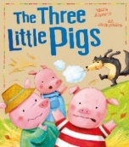 | 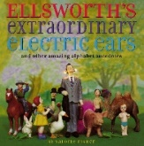  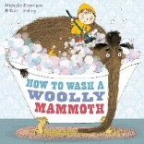 | 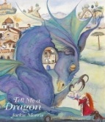  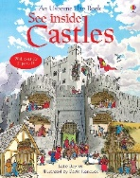 | 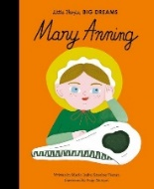  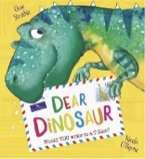 | 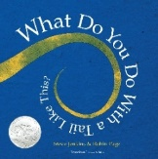 | 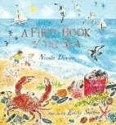  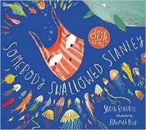
Topic | My Home | The workshop | Once upon a time! | Roar! | Let’s go on safari | Shipwrecked

Year 1/2 Second exposure
 | Autumn term |  |  | Spring term |  |  | Summer term
SPaG | Separate words with spaces.  Combine words to make sentences.  Co-ordinating conjunctions | Verbs  Demarcate sentences with capital letters and full stops.  Statement and commands (demarcated with a full stop)  Apostrophes for omission | Adjectives  Expanded noun phrases | Join words and clauses using ‘and’  Sequencing sentences to form short narratives  Capital letters for proper nouns  Coordinating and  Subordinating conjunctions | Demarcate sentences with capital letters and question marks  Verbs – ing, -ed, -er  Expanded noun phrases, Question sentences | Demarcate sentences with capital letters and exclamation marks.  Exclamation sentences  Apostrophes for possession.  Commas to separate items in a list | Adjectives and verbs  prefix –un  Sequencing sentences to form short narratives  Adjective suffixes -ful, -ness, -er, -est)  Progressive verbs | Application of Prefixes and suffixes  Commas to separate items in a list  Consistent use of tense | Use basic descriptive language.  Compound words  Expanded noun phrases  Noun suffixes -ness, -er  Adverbs
Text type | Fiction | Non-Fiction | Poetry | Fiction | Non-Fiction | Fiction | Fiction | Non-Fiction | Poetry
Year A  Suggested texts | 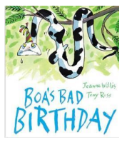 |  | 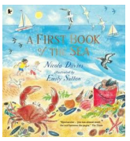 | 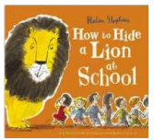 | 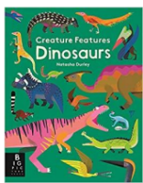 | 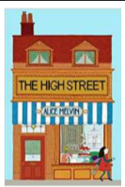 |  |  | 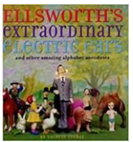
 | Non-fiction | Fiction | Poetry | Non fiction | Fiction | Fiction | Non fiction | Poetry | Fiction
Year B  Suggested texts |  | 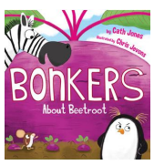 | 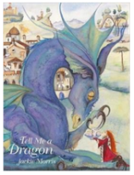 | 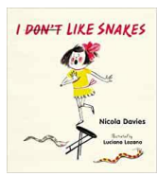 | 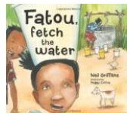 | 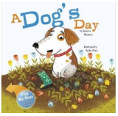 | 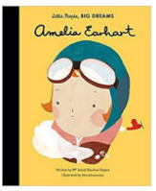 | 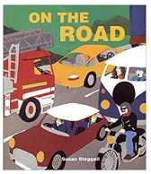 | 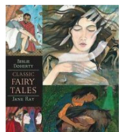

Year 3/4
 | Autumn term |  |  | Spring term |  |  | Summer term
SPaG | Express time, place and cause with adverbs (then, next, soon, therefore)  Fronted adverbials  Use of commas after fronted adverbials | Express time, place and cause with conjunctions, (when, before, after, in, because of)  Noun phrases expanded with modifying adjectives and nouns | Word families  Using correct form of a or an  Express time, place and cause with prepositions (before, after, during, in, because, of)  Noun phrases expanded with modifying preposition phrases | Inverted commas to punctuate direct speech  Inverted commas and other punctuation to punctuate direct speech | Headings and subheadings  Using correct forms of a or an  Paragraphs to organise ideas around a theme | Paragraphs to group related materials  Apostrophes to mark plural possession  Grammatical difference between plural and possessive -s | Noun prefixes (Super-, anti-, auto-)  Express time, place and cause with adverbs (then, next, soon, therefore)  Verb inflections  Fronted adverbials  Use of commas after fronted adverbials | Paragraphs to group related materials  Word families  Choice of pronoun or noun within and across sentence to aid cohesion and avoid repetition | Express time, place and cause with prepositions (before, after, during, in, because, of)  Noun phrases expanded with modifying adjectives and nouns
Text type | Fiction | Non-Fiction | Poetry | Fiction | Non-Fiction | Fiction | Fiction | Non-Fiction | Poetry
Year A  Suggested texts | 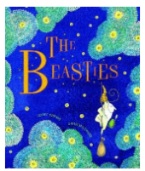 | 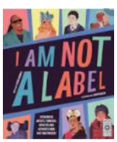 | 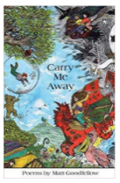 | 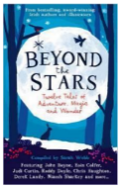 | 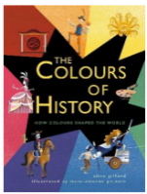 | 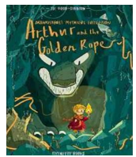 | 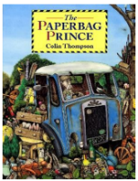 | 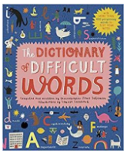
 | Poetry | Fiction | Non-fiction | Fiction | Fiction | Non -fiction | Poetry | Fiction | Non-Fiction
Year B  Suggested texts |  | 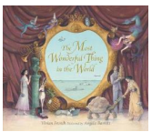 |  | 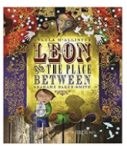 | 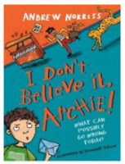 | 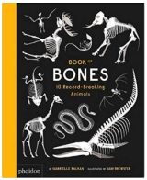 | 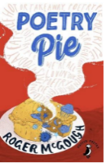 | 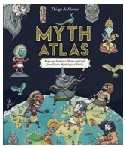 | .

Year 5/6
 | Autumn term |  |  | Spring term |  |  | Summer term
SPaG | Converting ro verbs using suffixes (-ate, -ise, -ify)  Synonyms and antonyms | Linking ideas across paragraphs using adverbials of time  Linking ideas across paragraphs using a wide range of cohesive devices.(Repetition of a word or phrases) | Linking ideas across paragraphs using adverbials of place  Relative clauses  Use of a colon to introduce a list  Use of semi-colons within a list. | Relative clauses  Parenthesis (Brackets, dashes, commas)  Use of semi colon, colon and dash to mark boundary between clauses | Devices to build cohesion (then, after that this, firstly  Linking ideas across paragraphs using a wide range of cohesive devices. (use of adverbials – on the otherhand, in contrast, as a consequence) | Use of commas to clarify meaning  Ellipsis  Passive voice | Use of commas to avoid ambiguity  Modal verbs  Hyphens to avoid ambiguity | Linking ideas across paragraphs using adverbials of number  Bullet points to list information  Differences between informal and formal speech | Verb prefixes (dis-, de-, mid-, over-, re-)  Passive voice
Text type | Poetry | Fiction | Non-Fiction | Fiction | Non-Fiction | Fiction | Fiction | Non-Fiction | Poetry
Year A  Suggested texts | 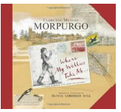 | 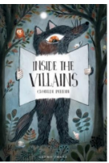 | 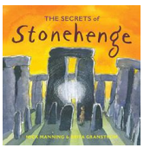 | 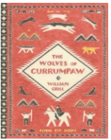 | 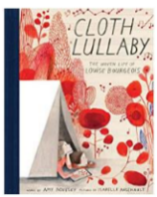 |  | 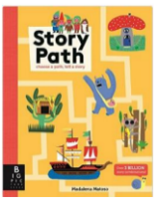 | 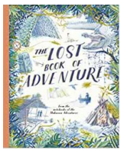
 | Poetry | Non-fiction | Fiction | Non-fiction | Fiction | Poetry | Poetry | Non- fiction | Fiction
Year B  Suggested texts | 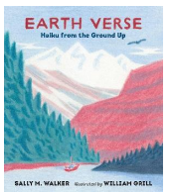 | 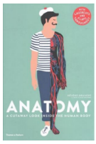 | 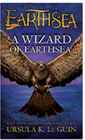 | 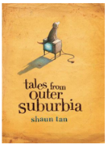 | 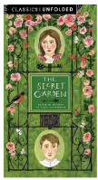 | 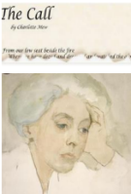 | 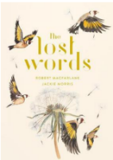 | 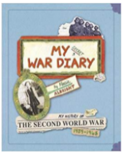 | 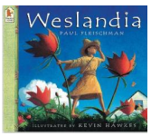

 | Progression in Writing
 | Reception | Year 1 | Year 2 | Year 3 | Year 4 | Year 5 | Year 6
Spelling – Phonic and whole word | *use their phonic knowledge to write words which match their spoken sounds  *write some irregular common words  *write some words spelt correctly  *name the letters of the alphabet. | *spell words containing each of the 40+ phonemes taught so far – most words can be deciphered  *spell most common exception words in the Y1 spelling appendix  *recognise and spell a set of simple compound words  *name the letters of the alphabet in order  *use letter names to distinguish between alternative spellings of the same sound | *segment spoken words into phonemes and represent these by graphemes, spelling many correctly  *learn new ways of spelling phonemes for which 1 or more spellings are already known – learn some words with each spelling including a few common homophones  *distinguish between homophones and near- homophones  *spell common exception words | *write words spelt ei, eigh or ey  *write words spelt ch eg: scheme, chemist, chef, brochure  *spell a range of common homophones eg: berry/bury, break/brake, grown/groan | *write words spelt sc eg: science, discipline, crescent  *write words ending with gue and que eg: league, tongue, antique  *spell most homophones in the Y3/Y4 spelling appendix eg: accept/except; scene/seen | *spell some homophones from the Y5/Y6 spelling appendix  *distinguish between some commonly confused words | *spelling some challenging homophones from the Y5/Y6 spelling appendix  *distinguish between many commonly confused words
Spelling – other word building | *write other words that are phonetically plausible | * use the prefix un-  *use the suffixes –ing, -ed -er - est where no change is made to the root word  *understand the rule for adding  -s or –es as the plural marker for nouns and the third person singular marker for verbs  *apply simple spelling rules and guidance from NC Appendix 1 | *spell more words with contracted forms  *use possessive apostrophe (singular)  *add suffixes to spell longer words including -ment, -ness,  -ful, -less, -ly  *apply spelling rules and guidance from NC Appendix 1 | *use knowledge of morphology to spell some words with prefixes dis-, mis-, in-, super-, anti-  *spell some words with the suffixes: -ation, -ly, -sure. –tion, - sion and –ssion  *embed use of apostrophe for a range of contractions and for singular nouns  *being to use apostrophes for plural possession  *spell some words from the Y3/Y4 Statutory Word List  *use dictionaries to aid checking of spelling | *use knowledge of morphology to spell words with prefixes in- il- im- re- sub- inter- auto-  *add suffixes which begin with a vowel eg: forget / forgetting  *add suffixes -ous, -sion, -ssion,  -tion, -cian and –ly from the full range from the Y3/Y4 spelling appendix  *use apostrophes to mark singular and plural possession  *spell the majority of the words from the Y3/Y4 Statutory word list  *use dictionaries independently to aid checking of spelling using  the first 2 or 3 letters of a word | *spell most words with prefixes and suffixes in Y3/Y4 spelling appendix and some from the Y5/Y6 list eg: - cious, -cial, -ant,  -ent, -ance, -ence  *spell correctly words with letters which are not sounded  *know when to use the hyphen to join a prefix to a root eg: re-enter  *spell the majority of words from the Y3/Y4 statutory word list and some words from the statutory Y5/Y6 list  *use the first 3 or 4 letters of a word to check spelling and/or  meaning in a dictionary | *use knowledge of morphology to spell words with the full range of prefixes and suffixes in the Y5/Y6 spelling appendix eg: pre- re-  -able, -ible , -ably, -ibly, -al, -ial  *use the appropriate range of spelling rules and conventions to spell polysyllabic words which conform to regular patterns  *spell the majority of words from the statutory Y5/Y6 word list  *independently and automatically use a dictionary to check the spelling / meaning of words when appropriate
Transcription |  | *write from memory simple dictated sentences containing the GPCs and words taught so far | *write from memory simple sentences dictated by the teacher that include words using the GPCs, common exception words and punctuation taught so far | *write from memory simple dictated sentences which include familiar GPCs, common exception words and punctuation – including the new punctuation  taught | *write from memory simple dictated sentences which include familiar GPCs, common exception words, words from the Y3/Y4 statutory word list and all  punctuation taught so far | *write from memory, dictated sentences which include words from the KS2 curriculum | *write from memory, dictated sentences which include words and punctuation from the KS2 curriculum
Handwriting |  | *sit correctly at a table, holding a pencil comfortably and correctly  *begin to form lower-case letters in the correct direction – starting and finishing in the right place  *form capital letters  *form digits 0-9  *understand which letters belong to which handwriting ‘families’ (eg: letters that are formed in similar ways) and practise these  *leave spaces between words | *form lower-case letters of the correct size relative to one another  *start using some of the diagonal and horizontal strokes needed to join letters and understand which letters, when adjacent to one another, are best left unjoined  *write capital letters and digits of the correct size, orientation and relationship to one another and to lower-case letters  *use spacing between words that reflects the size of the letters | *writing is legible  *letters are consistent in size and formation  *capital letters are the correct size relative to lower case  *writing is spaced sufficiently so that ascenders and descenders do not meet  *diagonal and horizontal strokes are used consistently to join letters  *know which letters, when adjacent, are best left unjoined  *appropriate letters are joined – consistent to the school’s handwriting approach | *writing is legible and fluent  *all letters and digits are consistently formed and of the correct size, orientation and relationship to one another  *downstrokes of letters are mostly parallel and equidistant  *writing is spaced sufficiently so that ascenders and descenders do not meet  *appropriate letters are joined consistently | *writing is legible and fluent and quality is beginning to be maintained at speed  *correct choices are usually made about whether to join handwriting or print letters eg: when labelling a diagram  *can usually choose the appropriate writing implement for the task | *writing is legible and fluent and quality is usually maintained when writing at a sustained, efficient speed  *correct choices are made about whether to join handwriting or print letters etc.. and handwriting is adapted according to purpose eg: when labelling a diagram; showing emphasis in dialogue  etc…  *chooses the writing implement that is best suited for a task
Contexts for writing |  |  | *write narratives about personal experiences and those of others (real and fictional)  *write about real events  *write poetry  *write for different purposes | *discuss writing similar to that which they are planning to write in order to understand its structure, vocabulary and grammar  *write to suit purpose showing some features of the genre being taught | *discuss writing similar to that which they are planning to write in order to identify and explain the purpose of its structure, vocabulary and grammar  *write to suit purpose and with a growing awareness of audience, using some appropriate features | *discuss the audience and purpose for a piece of writing  * with some support - select the appropriate form and use other similar writing as models for their own  *when writing narratives, consider ways in which characters and settings can be developed referring to books have read, listened to, seen performed | *confidently identify the audience and purpose for a piece of writing  *adapt form and style to suit the audience / purpose and draw appropriate features from models of similar writing  *when writing narratives, consider ways in which established authors have developed characters and settings in books the children have read, listened to, seen & performed
Planning |  | *say out loud what they are going to write about  *compose a sentence orally  before writing it | *plan or say out loud what they are going to write about | *talk about and record initial ideas  *compose and rehearse  sentences orally (inc dialogue) | *discuss and develop initial ideas in order to plan before writing | *discuss and develop a variety of initial ideas in order to plan before writing – choosing the most appropriate ideas to develop | *use discussion effectively to develop ideas and language before and during writing
Drafting | *write simple sentences which can be read by themselves and others | *sequence sentences to form short narratives | *write down ideas and/or key words including new vocabulary  *encapsulate what they want to say, sentence by sentence | *organise paragraphs broadly around a theme with some scaffolding  *write chronological narratives  *write in sequence  *describe characters, settings and/or plot in simple ways adding some interesting details | *organise writing into appropriate sections or paragraphs – both for fiction and non-fiction  *appropriately use a range of presentational devices including use of title and subheadings  *use dialogue [note: balance between dialogue and narrative may be uneven]  *describe characters, settings and plot with some appropriate interesting details | *organise writing into sections or paragraphs, create cohesion by linking ideas within paragraphs  *use a range of presentational devices including use of title, subheadings and bullet points  *use dialogue to indicate character and event  *describe characters, setting and plot with growing precision  *find key words and ideas – begin to write summaries | *organise and shape paragraphs effectively – develop and expand some ideas in depth, adding detail within each paragraph  *use a range of devices to link ideas within and across paragraphs eg: precise adverbials, deliberate repetition, sustained tense  *use a range of presentational devices which clearly guide the reader eg: bullet points, tables, columns  *integrate dialogue to convey and contrast characters and to advance the action  *describe characters, settings and atmosphere with some precision  *use complex plot structures  *write an accurate précis
Editing |  | *discuss what they have written with the teacher or other pupils  *re-read what they have written to check that it makes sense | *evaluate their writing with the teacher and other pupils  *re-read to check that their writing makes sense and that verbs to indicate time are used correctly and consistently – including verbs in the continuous form  *proof-read to check for errors in spelling, grammar and punctuation | *evaluate own and others’ writing  – with direction  *re-read and check own writing against agreed criteria linked to spelling, grammar, punctuation and vocabulary  *make changes to their own writing following a re-read | *evaluate own and others’ writing making suggestions for improvements including content, grammar and vocabulary  *proof-read, edit and revise their own work | *evaluate own and others’ writing: proof-read, edit and revise – making changes which clarify descriptions and meaning  *proof-read to ensure consistent and correct use of tense through a piece of writing; accurate spelling and punctuation | *evaluate own and others’ writing: proof-read, edit and revise – making assured changes to enhance effects and clarify meaning  *proof-read to ensure correct subject and verb agreement when using singular and plural – distinguishing between the language of speech and writing and choosing the appropriate register
Performing |  | *read their writing aloud, clearly enough to be heard by their peers and the teacher | *read aloud what they have written with appropriate intonation to make the meaning clear | *read their own writing aloud to a group or whole class with appropriate intonation to make that the meaning is clear and sufficient volume to be heard | *read their own writing aloud to a group or whole class, using appropriate intonation and controlling the tone and volume so that the meaning is clear | *perform their own compositions using appropriate intonation, volume and movement so that the meaning is clear – beginning to show an awareness of audience | *confidently perform their own compositions using appropriate intonation, volume and movement so that the meaning is clear –showing a developed awareness of audience
Vocabulary |  | *join words and clauses using “and” | *expanded noun phrases to describe and specify | *extend the range of sentences with more than one clause by using a wider range of conjunctions including: when, if, because, although, after, while, before, so | *develop vocabulary range to develop a wider range of word choices for adjectives, adverbs, conjunctions etc… | *begin to use a thesaurus to expand vocabulary  *choose vocabulary and grammar to suit formal and informal writing  – with guidance  *use vocabulary which is becoming more precise | *confidently use a thesaurus to find precise word choices and further expand vocabulary  *select vocabulary and grammar to suit formal and informal writing with growing precision  *use vocabulary which is varied,  interesting and precise
Grammar |  |  | *use sentences with different forms – statement, question, exclamation, command  *use the present and past tenses correctly and consistently- including the progressive form  *use subordination (when, if, that, because) and coordination (or and but)  *use some features of written Standard English  *suffixes to form new words (-ful,  -er. –ness) | *use a range of sentence types which are usually grammatically accurate eg: commands, questions, statements  *use coordinating and simple subordinating conjunctions to join clauses  *identify and use a range of prepositions  *consolidate knowledge of word classes: noun, adjective, verb, adverb  *use a or an according to whether the next word begins with a consonant or vowel  *use the past or present tense appropriate; sometimes use the present perfect eg: He has gone out to play. | *use a range of sentence types which are grammatically accurate and begin to use sentences containing more than one clause  *use a variety of coordinating and subordinating conjunctions accurately  *use sequencing conjunctions  *vary sentence openers – including using fronted adverbials  *use expanded noun phrases and adverbial phrases to expand sentences  *identify the correct determiner eg: a, an, these, those  *use the appropriate pronoun or noun within and across sentences to aid cohesion /avoid repetition  *usually use the past or present tense and 1st / 3rd person  consistently | *write a range of sentence structures which are grammatically accurate  *understand ‘relative clause’ begins with relative pronouns – who, which, where, when, whose  *indicate degrees of possibility using adverbs eg: perhaps, surely  *indicate degrees of possibility using modal verbs  *recognise the subjunctive form of the verb when appropriate  *usually maintain the correct tense  *begin to recognise active and passive voice  *identify and select determiners (understand articles as specific determiners an, the, a) | *write a range of sentence structures (simple and complex) including relative clauses eg: using that, which  *use modal verbs with precision to indicate degrees of possibility  *maintain correct tense and control perfect form of verbs eg: He has collected some shells.  *recognise and use the subjunctive form of the verb when appropriate  *understand and use active and passive voice (to show the flow of ‘power’)  *identify the subject and object  *identify synonyms and antonyms
Punctuation |  | *begin to punctuate sentences using a capital letter and a full stop, question mark or exclamation mark  *use a capital letter for names of people, places, days of the week and the personal pronoun I | *use familiar and new punctuation correctly including – full stops, capital letters, exclamation marks, question marks, commas for lists and apostrophes for omission and singular possession | *demarcate sentences with increasing security including capital letters, full stops, question marks, exclamation marks; commas to separate items in lists and apostrophe for both omission and possession  *identify direct speech and begin to use inverted commas for direct  speech | *use sentence demarcation with accuracy including capital letters, full stops, question marks, exclamation marks, commas to separate items in lists and for fronted adverbials and use apostrophes correctly for both omission and possession  *use inverted commas accurately for direct speech | *demarcate sentences correctly – use a comma for a pause in complex sentences  *begin to use punctuation for parenthesis: brackets, commas and dashes | *use a wide range of punctuation including brackets and dashes; commas for pauses; colons and semi-colons for lists; hyphens; ellipsis; consistent use of bullet points
Grammatical Terminology |  | *letter, capital letter, word, singular, plural, sentence, punctuation, full stop, question mark, exclamation mark | *noun, noun phrase, statement, question, exclamation, command, compound, suffix, adjective, adverb, verb, past tense, present tense, apostrophe, comma | *preposition, conjunction, word family, prefix, clause, subordinate clause, direct speech, consonant, consonant letter, vowel, vowel letter, inverted commas (speech  marks) | *determiner, pronoun, possessive pronoun, adverbial, fronted adverbial | *modal verb, relative pronoun, relative clause, parenthesis, bracket, dash, cohesion, ambiguity | *subject, object, active, passive, synonym, antonym, ellipsis, hyphen, colon, semi-colon, bullet points

